I UNIT
Special Semi conductor devices:
S.C.R (Silicon Controlled Rectifier)
The silicon controlled rectifier SCR, is one of several power semiconductor devices, capable of acting like very fast solid state AC switches for controlling large AC voltages and currents.
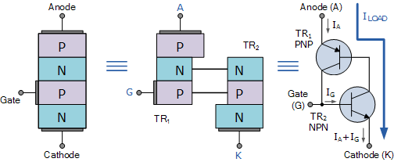
SCR is a three-terminal device labeled: “Anode”, “Cathode” and “Gate” and consisting of three PN junctions which can be switched “ON” and “OFF” at an extremely fast rate, or it can be switched “ON” for variable lengths of time during half cycles to deliver a selected amount of power to a load. The operation of SCR can be best explained by assuming it to be made up of two transistors connected back-to-back as a pair of complementary regenerative switches as shown in the above circuit.
The two transistor equivalent circuit shows that the collector current of the NPN transistor TR₂ feeds directly into the base of the PNP transistor TR₁, while the collector current of TR₁ feeds into the base of TR₂. These two inter-connected transistors rely upon each other for conduction as each transistor gets its base-emitter current from the other’s collector-emitter current. So until one of the transistors is given some base current nothing can happen even if an Anode-to-Cathode voltage is present.
If the Anode terminal is made positive with respect to the Cathode, the two outer P-N junctions are now forward biased but the centre N-P junction is reverse biased. Therefore forward current is also blocked. If a positive current is injected into the base of the NPN transistor TR₂, the resulting collector current flows in the base of transistor TR₁. This in turn causes a collector current to flow in the PNP transistor, TR₁ which increases the base current of TR₂ and so on.
Very rapidly the two transistors force each other to conduct to saturation as they are connected in a regenerative feedback loop that can not stop. Once triggered into conduction, the current flowing through the device between the Anode and the Cathode is limited only by the resistance of the external circuit as the forward resistance of the device when conducting can be very low at less than 1Ω so the voltage drop across it and power loss is also low.
Then we can see that SCR blocks current in both directions of an AC supply in its “OFF” state and can be turned “ON” and made to act like a normal rectifying diode by the application of a positive current to the base of transistor, TR₂ which for a silicon controlled rectifier is called the “Gate” terminal.
The operating voltage-current I-V characteristics curves for the operation of a Silicon Controlled Rectifier are given as:

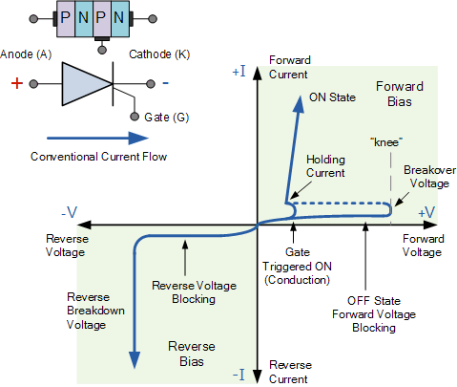

Once the SCR has self-latched into its “ON” state and passing a current, it can only be turned “OFF” again by either removing the supply voltage and therefore the Anode (I_{A}) current completely, or by reducing its Anode to Cathode current by some external means (the opening of a switch for example) to below a value commonly called the “minimum holding current”, I_{H}.
The Anode current must therefore be reduced below this minimum holding level long enough for the thyristors internally latched PN-junctions to recover their blocking state before a forward voltage is again applied to the device without it automatically self-conducting.
Silicon Controlled Rectifiers known commonly as Thyristors are three-junction PNPN semiconductor devices which can be regarded as two inter-connected transistors that can be used in the switching of heavy electrical loads. They can be latched-“ON” by a single pulse of positive current applied to their Gate terminal and will remain “ON” indefinitely until the Anode to Cathode current falls below their minimum latching level.

Static Characteristics of a Thyristor:
- Thyristors are semiconductor devices that can operate only in the switching mode.
- Thyristor are current operated devices, a small Gate current controls a larger Anode current.
- Conducts current only when forward biased and triggering current applied to the Gate.
- The thyristor acts like a rectifying diode once it is triggered “ON”.
- Anode current must be greater than holding current to maintain conduction.
- Blocks current flow when reverse biased, no matter if Gate current is applied.
- Once triggered “ON”, will be latched “ON” conducting even when a gate current is no longer applied providing Anode current is above latching current.
Thyristors are high speed switches that can be used to replace electromechanical relays in many circuits as they have no moving parts, no contact arcing or suffer from corrosion or dirt. But in addition to simply switching large currents “ON” and “OFF”, thyristors can be made to control the mean value of an AC load current without dissipating large amounts of power. A good example of Thyristors power control is in the control of electric lighting, heaters and motor speed
DIAC:
The DIAC is a full-wave or bi-directional semiconductor switch that can be turned on in both forward and reverse polarities. The DIAC gains its name from the contraction of the words DIode Alternating Current.
The DIAC is widely used to assist even triggering of a TRIAC when used in AC switches. DIACs are mainly used in dimmer applications and also in starter circuits for florescent lamps.

Circuit symbol
The DIAC circuit symbol is generated from the two triangles held between two lines as shown below. In some way this demonstrates the structure of the device which can be considered also as two junctions.
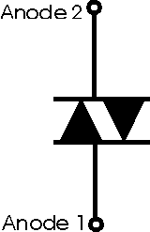
Circuit symbol for the DIAC
The two terminals of the device are normally designated either Anode 1 and Anode 2 or Main Terminals 1 and 2, i.e. MT1 and MT2.

Operation
The DIAC is essentially a diode that conducts after a 'break-over' voltage, designated VBO, is exceeded.
When the device exceeds this break-over voltage, it enters the region of negative dynamic resistance. This results in a decrease in the voltage drop across the diode with increasing voltage. Accordingly there is a sharp increase in the level of current that is conducted by the device.
The diode remains in its conduction state until the current through it drops below what is termed the holding current, which is normally designated by the letters IH.
Below the holding current, the DIAC reverts to its high-resistance (non-conducting) state.
Its behavior is bi-directional and therefore its operation occurs on both halves of an alternating cycle.

DIAC applications:
Typically the DIAC is placed in series with the gate of a TRIAC. DIACs are often used in conjunction with TRIACs because these devices do not fire symmetrically as a result of slight differences between the two halves of the device. This results in harmonics being generated, and the less symmetrical the device fires, the greater the level of harmonics produced. It is generally undesirable to have high levels of harmonics in a power system.
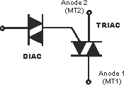
Typical DIAC / TRIAC circuit configuration
To help in overcoming this problem, a DIAC is often placed in series with the gate. This device helps make the switching more even for both halves of the cycle. This results from the fact that its switching characteristic is far more even than that of the TRIAC. Since the DIAC prevents any gate current flowing until the trigger voltage has reached a certain voltage in either direction, this makes the firing point of the TRIAC more even in both directions.

Structure:

The DIAC can be fabricated as either a two layer or a five layer structure. In the three layer structure the switching occurs when the junction that is reverse biased experiences reverse breakdown. The three layer version of the device is the more common and can have a break-over voltage of around 30 V. Operation is almost symmetrical owing to the symmetry of the device.

A five layer DIAC structure is also available. This does not act in quite the same manner, although it produces an I-V curve that is very similar to the three layer version. It can be considered as two break-over diodes connected back to back.
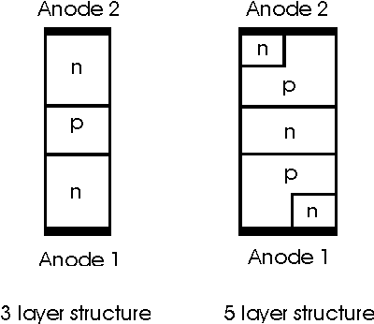
The structure of a DIAC
For most applications a three layer version of the DIAC is used. It provides sufficient improvement in switching characteristics. For some applications the five layer device may be used.
TRIAC:
The TRIAC is a three terminal semiconductor device for controlling current. It gains its name from the term TRIode for Alternating Current. The TRIAC is a bidirectional device.
The TRIAC is an ideal device to use for AC switching applications because it can control the current flow over both halves of an alternating cycle.

TRIAC symbol:
The circuit symbol recognises the way in which the TRIAC operates. Seen from the outside it may be viewed as two back to back thyristors and this is what the circuit symbol indicates.
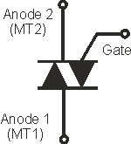
TRIAC symbol for circuit diagrams
The three terminals of the TRIAC are the Gate and two other terminals are often referred to as an "Anode" or "Main Terminal". As the TRIAC has two of these they are labelled either Anode 1 and Anode 2 or Main Terminal, MT1 and MT2.

TRIAC basics:
The TRIAC is a component, which provides AC switching for electrical systems. They find particular use for circuits in light dimmers, etc., where they enable both halves of the AC cycle to be used. This makes them more efficient in terms of the usage of the power available. While it is possible to use two thyristors back to back, this is not always cost effective for low cost and relatively low power applications.
It is possible to view the operation of a TRIAC in terms of two thyristors placed back to back.
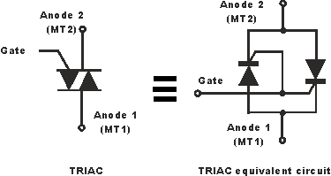
One of the drawbacks of the TRIAC is that it does not switch symmetrically. It will often have an offset, switching at different gate voltages for each half of the cycle.

Advantages | Disadvantages
- Can switch both halves of an AC waveform  - Single component can be used for full AC switching | - A TRIAC does not fire symmetrically on both sides of the waveform  - Switching gives rise to high level of harmonics due to non-symmetrical switching  - More susceptible to EMI problems as a result of the non-symmetrical switching  - Care must be taken to ensure the TRIAC turns off fully when used with inductive loads

Applications:
TRIACs are used in a number of applications. However they tend not to be used in high power switching applications - one of the reasons for this is the non-symmetrical switching characteristics. For high power applications this creates a number of difficulties, especially with electromagnetic interference.
TRIACs are still used for many electrical switching applications:
- Domestic light dimmers
- Electric fan speed controls
- Small motor controls
- Control of small AC powered domestic appliances
The TRIAC is easy to use and provides cost advantages over the use of two thyristors for many low power applications. Where higher powers are needed, two thyristors placed in "anti-parallel" are almost always used.
The TRIAC is an electronic component that is widely used in many circuit applications, ranging from light dimmers through to various forms of AC control. It is generally only used for lower power applications, thyristors generally being used for the high power switching circuits.

Unijunction Transistor:
The Unijunction Transistor or UJT for short, is another solid state three terminal device that can be used in gate pulse, timing circuits and trigger generator applications to switch and control either thyristors and triacs for AC power control type applications.
Like diodes, unijunction transistors are constructed from separate P-type and N-type semiconductor materials forming a single (hence its name Uni-Junction) PN-junction within the main conducting N-type channel of the device.
UJT’s have unidirectional conductivity and negative impedance characteristics acting more like a variable voltage divider during breakdown.
The UJT consists of a single solid piece of N-type semiconductor material forming the main current carrying channel with its two outer connections marked as Base 2 ( B₂ ) and Base 1 ( B₁ ). The third connection, confusingly marked as the Emitter ( E ) is located along the channel. The emitter terminal is represented by an arrow pointing from the P-type emitter to the N-type base.
The Emitter rectifying p-n junction of the unijunction transistor is formed by fusing the P-type material into the N-type silicon channel. However, P-channel UJT’s with an N-type Emitter terminal are also available but these are little used.
The Emitter junction is positioned along the channel so that it is closer to terminal B₂ than B₁. An arrow is used in the UJT symbol which points towards the base indicating that the Emitter terminal is positive and the silicon bar is negative material. Below shows the symbol, construction, and equivalent circuit of the UJT.

Unijunction Transistor Symbol and Construction:
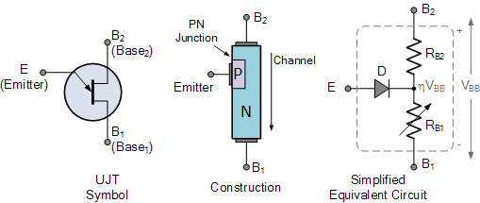

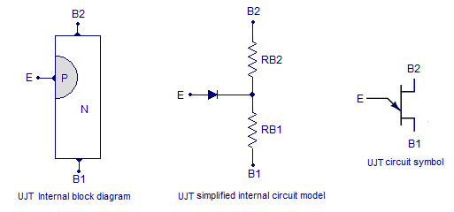

From the equivalent circuit above, that the N-type channel basically consists of two resistors R_{B2} and R_{B1} in series with an equivalent (ideal) diode, D representing the p-n junction connected to their center point. This Emitter p-n junction is fixed in position along the ohmic channel during manufacture and can therefore not be changed.
Resistance R_{B1} is given between the Emitter, E and terminal B₁, while resistance R_{B2} is given between the Emitter, E and terminal B₂. As the physical position of the p-n junction is closer to terminal B₂ than B₁ the resistive value of R_{B2} will be less than R_{B1}.
The total resistance of the silicon bar (its Ohmic resistance) will be dependent upon the semiconductors actual doping level as well as the physical dimensions of the N-type silicon channel but can be represented by R_{BB}. If measured with an ohmmeter, this static resistance would typically measure somewhere between about 4kΩ and 10kΩ’s for most common UJT’s such as the 2N1671, 2N2646 or the 2N2647.
These two series resistances produce a voltage divider network between the two base terminals of the uni-junction transistor and since this channel stretches from B₂ to B₁, when a voltage is applied across the device, the potential at any point along the channel will be in proportion to its position between terminals B₂ and B₁. The level of the voltage gradient therefore depends upon the amount of supply voltage.When used in a circuit, terminal B₁ is connected to ground and the Emitter serves as the input to the device. Suppose a voltage V_{BB} is applied across the UJT between B₂ and B₁ so that B₂ is biased positive relative to B₁. With zero Emitter input applied, the voltage developed across R_{B1} (the lower resistance) of the resistive voltage divider can be calculated as:

Unijunction Transistor: R_{B1} Voltage:


UJT parameters.
R_{BBO} : It is the resistance between the terminals B1 and B2. In simple words, it is the resistance of the N-Type bar when measured lengthwise. If RB1 is resistance of the bar from E to B1 and RB2 is the resistance of the bar from E to B2, then R_{BBO} can be expressed as R_{BBO}= RB1 +RB2. The typical range of R_{BBO} is from 4KΩ to 10KΩ.
Intrinsic standoff ratio (η) : It is the ratio of RB1 to the sum of RB1 and RB2. It can be expressed as η = RB1/(RB1+RB2) or η = RB1/R_{BBO}. The typical range of intrinsic standoff ratio is from 0.4 to 0.8.

UJT characteristics and circuit arrangement.
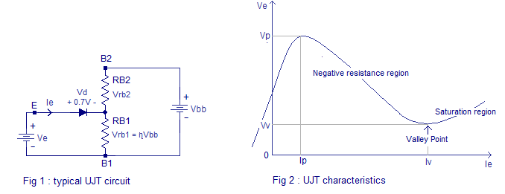
For ease of understanding, the internal model of the UJT is used in the circuit. B2 terminal of the UJT is made positive with respect to B1 terminal using the voltage source Vbb. Emitter terminal E of the UJT is forward biased using the voltage source Ve. Current starts flowing into the emitter only when the bias voltage Ve has exceeded the forward drop of the internal diode (Vd) plus the voltage drop across RB1 (Vrb1). This condition can be expressed using the following equation.
Ve = Vd + Vrb1
Considering the intrinsic stand off ratio η= RB1/(RB1+RB2), the equation becomes
Ve = Vd+ηVbb
A typical silicon diode has a forward voltage drop of 0.7V. When this factor is considered, the equation can be re written as
Ve = 0.7V + ηVbb
This minimum value of the emitter voltage Ve for which the emitter current starts to flow is called the firing voltage of UJT.
As the Ve is increased the emitter current Ie is also increased and the junction behaves like a typical P-N junction. But the Ve can be only increased up to a particular point called Vp (peak voltage). At this point a considerable amount of emitter current (Ie) flows and a significant number of holes are injected into the junction. These holes are repelled by B2 and attracted by B1. As a result the region between emitter(E) and B1 terminal starts saturating by holes and the conductivity of this region starts to increase. This phenomenon of increasing conductivity by the insertion of holes is called conductivity modulation. This increased conductivity reduces RB1 and η. This results in a condition where emitter current Ie increases and the emitter voltage Ve decreases. This situation is similar to a negative resistance scenario. In the graph (Fig:2) you can see that the regions between Vp (peak voltage point) and Vv (valley voltage) has a negative slope. This negative resistance region in the UJT characteristics is employed in relaxation oscillators.
At last the emitter current Ie will be increased to a point that no more increase in conductivity is possible. This point is called “Valley point”. The emitter current corresponding to valley point is denoted as Iv and the corresponding emitter voltage is denoted as Vv. Beyond the valley point the UJT is fully saturated and the junction behaves like a fully saturated P-N junction.

Applications of UJT.
- Relaxation oscillators.
- Switching Thyristors like SCR, TRIAC etc.
- Magnetic flux sensors.
- Voltage or current limiting circuit.
- Bistable oscillators.
- Voltage or current regulators.
- Phase control circuits.
Junction Diode Symbol and Static I-V Characteristics.
A PN Junction Diode is one of the simplest semiconductor devices around, and which has the characteristic of passing current in only one direction only.If a suitable positive voltage (forward bias) is applied between the two ends of the PN junction, it can supply free electrons and holes with the extra energy they require to cross the junction as the width of the depletion layer around the PN junction is decreased.
By applying a negative voltage (reverse bias) results in the free charges being pulled away from the junction resulting in the depletion layer width being increased. This has the effect of increasing or decreasing the effective resistance of the junction itself allowing or blocking current flow through the diode.
Then the depletion layer widens with an increase in the application of a reverse voltage and narrows with an increase in the application of a forward voltage. This is due to the differences in the electrical properties on the two sides of the PN junction resulting in physical changes taking place. One of the results produces rectification as seen in the PN junction diodes static I-V (current-voltage) characteristics. Rectification is shown by an asymmetrical current flow when the polarity of bias voltage is altered as shown below.

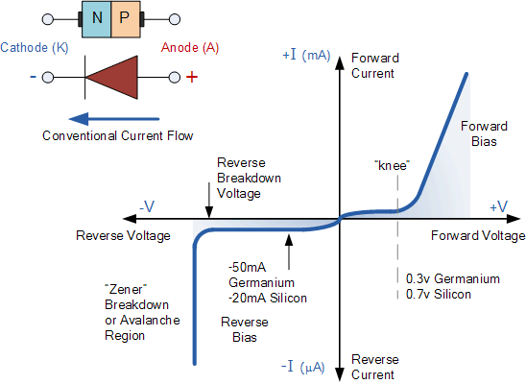
There are two operating regions and three possible “biasing” conditions for the standard Junction Diode and these are:
- 1. Zero Bias – No external voltage potential is applied to the PN junction diode.
- 2. Reverse Bias – The voltage potential is connected negative, (-ve) to the P-type material and positive, (+ve) to the N-type material across the diode which has the effect of Increasing the PN junction diode’s width.
3. Forward Bias – The voltage potential is connected positive, (+ve) to the P-type material and negative, (-ve) to the N-type material across the diode which has the effect of Decreasing the PN junction diodes width
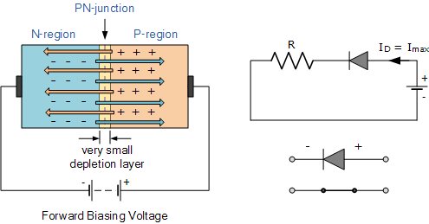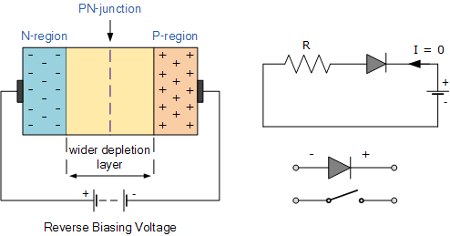

Junction Diode Ideal and Real Characteristics
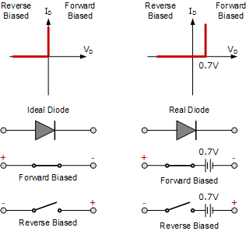
Diode rectifiers

Rectification
An alternating current has the property to change its state continuously. This is understood by observing the sine wave by which an alternating current is indicated. It raises in its positive direction goes to a peak positive value, reduces from there to normal and again goes to negative portion and reaches the negative peak and again gets back to normal and goes on.
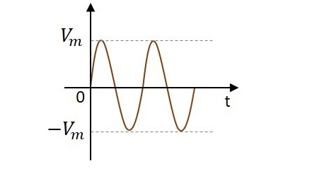

During its journey in the formation of wave, we can observe that the wave goes in positive and negative directions. Actually it alters completely and hence the name alternating current. But during the process of rectification, this alternating current is changed into direct current DC. The wave which flows in both positive and negative direction till then, will get its direction restricted only to positive direction, when converted to DC. Hence the current is allowed to flow only in positive direction and resisted in negative direction, just as in the figure below.
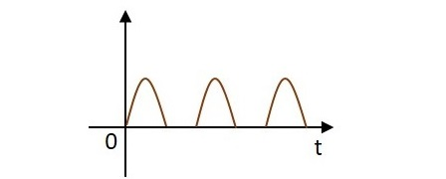
The circuit which does rectification is called as a Rectifier circuit. A diode is used as a rectifier, to construct a rectifier circuit.

Types of Rectifier circuits:There are two main types of rectifier circuits, depending upon their output. They are
- Half-wave Rectifier
- Full-wave Rectifier
A Half-wave rectifier circuit rectifies only positive half cycles of the input supply whereas a Full-wave rectifier circuit rectifies both positive and negative half cycles of the input supply.

Half-Wave Rectifier
The name half-wave rectifier itself states that the rectification is done only for half of the cycle. The AC signal is given through an input transformer which steps up or down according to the usage. Mostly a step down transformer is used in rectifier circuits, so as to reduce the input voltage.
The input signal given to the transformer is passed through a PN junction diode which acts as a rectifier. This diode converts the AC voltage into pulsating dc for only the positive half cycles of the input. A load resistor is connected at the end of the circuit. The figure below shows the circuit of a half wave rectifier.

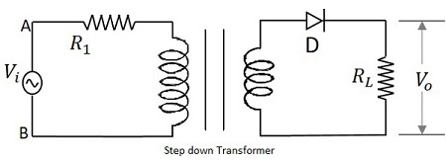

Working of a HWR
The input signal is given to the transformer which reduces the voltage levels. The output from the transformer is given to the diode which acts as a rectifier. This diode gets ON (conducts) for positive half cycles of input signal. Hence a current flows in the circuit and there will be a voltage drop across the load resistor. The diode gets OFF (doesn’t conduct) for negative half cycles and hence the output for negative half cycles will be, i_{D}=0
and Vo=0.
Hence the output is present for positive half cycles of the input voltage only (neglecting the reverse leakage current). This output will be pulsating which is taken across the load resistor.

Waveforms of a HWR
The input and output waveforms are as shown in the following figure.

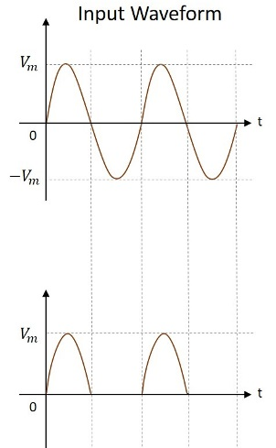

Analysis of Half-Wave Rectifier
To analyze a half-wave rectifier circuit, let us consider the equation of input voltage.
V_{i}=V_{m}SinWt
Vm is the maximum value of supply voltage.

Let us assume that the diode is ideal.
The resistance in the forward direction, i.e., in the ON state is Rf

The resistance in the reverse direction, i.e., in the OFF state is Rr.
The current i in the diode or the load resistor R_{L} is given by
I =I_{m}SinWt for 0<=Wt<=π;
I=0 for π<=Wt<=2π;
Where I_{m} = V_{m}/ (R_{f}+R_{L});

FILTERS:
Full-wave Rectifier with Shunt Capacitor Filter
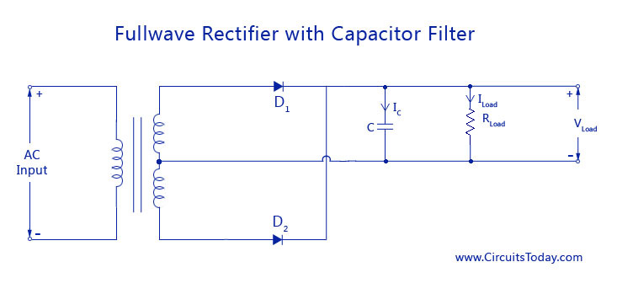
The circuit diagram of a full-wave rectifier wit capacitor filter is shown below
The filter capacitor C is placed across the resistance load R _{Load.} The working is much similar to that of a half-wave rectifier with shunt capacitor. The only difference is that two pulses of current will charge the capacitor during alternate positive (D1) and negative (D2) half cycles. Similarly capacitor C discharges twice through RLoad during one full cycle. This is shown in the waveform below.
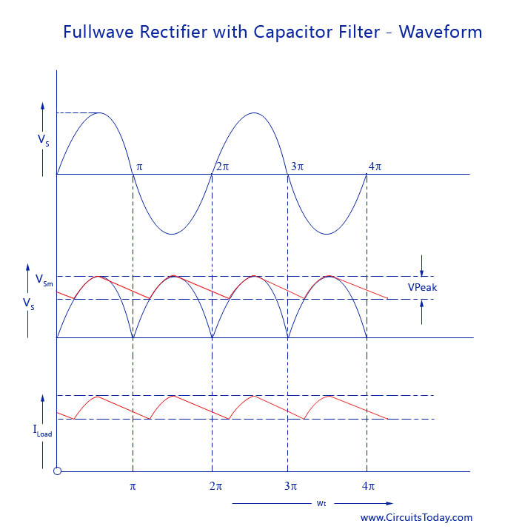

L-C Filters
In the simple shunt capacitor filter circuit explained above, we have concluded that the capacitor will reduce the ripple voltage, but causes the diode current to increase .This large current may damage the diode and will further cause heating problem and decrease the efficiency of the filter. On the other hand, a simple series inductor reduces both the peak and effective values of the output current and output voltage. Then if we combine both the filter (L and C), a new filter called the L-C filter can be designed which will have a good efficiency, with restricted diode current and enough ripple removal factor .The voltage stabilizing action of shunt capacitor and the current smoothing action of series inductor filter can be combined to form a perfect practical filter circuit.
L-C filters can be of two types: Choke Input L-section Filter and L-C Capacitor input filter

Choke Input L-Section Filter
An inductor filter increases the ripple factor with the increase in load current Rload. A capacitor filter has an inversely proportional ripple factor with respect to load resistance. Economically, both inductor filter and capacitor filter are not suitable for high end purpose
L-C inductor input or L-section filter consists of an inductor ‘ L’ connected in series with a half or full wave rectifier and a capacitor ’C’ across the load. This arrangement is also called a choke input filter or L-section filter because it’s shape resembles and inverted L-shape. To increase the smoothing action using the filter circuit, just one L-C circuit will not be enough. Several L-section filters will be arranged to obtain a smooth filtered output. The circuit diagram and smoothened waveform of a Full wave rectifier output is shown below.

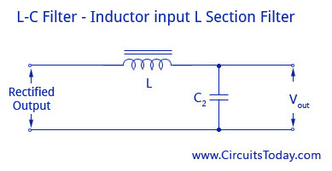
L-C Filter Inductor input L-Section Filter
As shown in the circuit diagram above, the inductor L allows the dc to pass but restricts the flow of ac components as its dc resistance is very small and ac impedance is large. After a signal passes through the choke, if there is any fluctuation remaining the current, it will be fully bypassed before it reaches the load by the shunt capacitor because the value of Xc is much smaller than Rload. The number of ripples can be reduced to a great amount by making the value of XL greater than Xc at ripple frequency.
Ripple Factor
Ripple Factor = Vac rms/Vdc = (√2/3)(Xc/X_{L}) = (√2/3)(1/[2wc])(1/[2wL]) = 1/(6√2w²LC)
Though the L-C filter has all these advantages, it has now become quite obsolete due the huge size of inductors and its cost of manufacturing. Nowadays, IC voltage regulators are more commonly used along with active filters, that reduce the ripples and keeps the output dc voltage constant.
The diagram of L-C Capacitor input filter and waveform is shown below.

Π – Filter or Capacitance Input Filter
The name pi – Filter implies to the resemblance of the circuit to a Π shape with two shunt capacitances (C1 and C2) and an inductance filter ‘L’. As the rectifier output is provided directly into the capacitor it also called a capacitor input filter.
The output from the rectifier is first given to the shunt capacitor C. The rectifier used can be half or full wave and the capacitors are usually electrolytic even though they large in size. In practical applications, the two capacitances are enclosed in a metal container which acts as a common ground for the two capacitors. Circuit diagram and the waveform are given below.
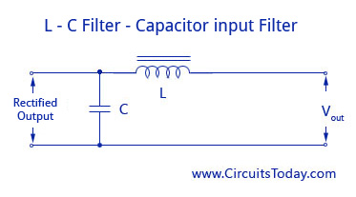
L-C Filter-Capacitor input Filter
When compared to other type of filters, the Π – Filter has some advantages like higher dc voltage and smaller ripple factor. But it also has some disadvantages like poor voltage regulation, high peak diode current, and high peak inverse voltage.
This filter is divided into two – a capacitor filter and a L-section filter. The capacitor C1 does most of the filtering in the circuit and the remaining ripple os removed by the L-section filter (L-C2). C1 is selected to provide very low reactance to the ripple frequency. The voltage regulation is poor for this circuit as the output voltage falls off rapidly with the increase in load current.
Ripple Factor
Ripple Factor = √2/(8w³C₁C₂LR_{load})

UNIT –II BJT Amplifiers
Biasing of BJT
Biasing refers to the application of D.C. voltages to setup the operating point in such a way that output signal is undistorted throughout the whole operation. Also once selected properly, the Q point should not shift because of change of IC due to
(i) β variation due to replacement of the transistor of same type
(ii) Temperature variation
Stabilization
The process of making operating point independent of temperature changes or variation in transistor parameters is known as stabilization.
Stabilization of operating point is necessary due to
Temperature dependence of I_{C}
Individual variations
Thermal runaway
Temperature dependence of I_{C} & Thermal runaway
I_{C} = βI_{B} + (β + I)I _{CBO}
I_{CBO} is strong function of temperature. A rise of 10ºC doubles the I_{CBO} and I_{C}
will increase ( β+1) times of I_{CBO.}
The flow of I_{C} produce heat within the transistor and raises the transistor
temperature further and therefore, further increase in I_{CBO.} This effect is cumulative and in few seconds, the I_{C} may become large enough to burn out the transistor. The self destruction of an un-stabilized transistor is known as thermal runaway.
Stability Factor:
The rate of change collector current I_{C} with respect to the collector leakage
current I_{CBO} is called stability factor, denoted by S = (dI_{c}/dI_{CBO})
Lower the value of S, better is the stability of the transistor.
The rate of change collector current IC with respect to the collector leakage current I_{CBO} at constant β and I_{B} is called stability factor, denoted by S.
I_{C} = βI_{B} + (β + I)I _{CBO} …………….(1)
Differentiating equation (1) w.r.t I_{C}
1= β (dI_{B}/dI_{C})+ β+1(d I _{CBO} /d I_{C}) ……………(2)
1= β (dI_{B}/dI_{C}) + ( β+1 )/ S …………………. (3)
S = ( β+1 )/ (1-β( dI_{B}/dI_{C})) ………………. (4)

Different biasing schemes:
(i) Fixed bias (base resistor biasing)
(ii) Collector base bias
(iii) Voltage divider bias
Fixed Bias
This form of biasing is also called base bias. The single power source is used for both collector and base of transistor, although separate batteries can also be used.
Using KVL in the base-emitter loop 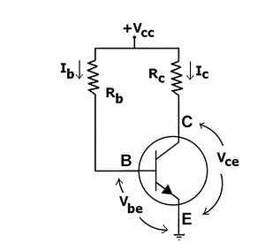
V_{CC} – I_{b}R_{b} –V_{be} = 0 ; I_{b}= (V_{CC}-V_{be})/R_{b} ;
I_{C} = βI_{b}= β(V_{CC}-V_{be})/R_{b} ;
Using KVL in the collector-emitter loop;
V_{CC} – I_{C}R_{C} –Vce = 0; V_{ce} = V_{CC} - I_{C}R_{C} ;
Advantages:
Operating point can be shifted easily anywhere in the active region by merely
changing the base resistor (RB).
A very small number of components are required.
Disadvantages:
Poor stabilization. High stability factor(S=β+1 because I_{B} is constant so (dI_{B}/dI_{C} =0 ), hence
prone to thermal runaway.
Usage:
Due to the above inherent drawbacks, fixed bias is rarely used in linearcircuits (i.e., those circuits which use the transistor as a current source).Instead, it is often used in circuits where transistor is used as a switch.
Collector base bias
This configuration employs negative feedback to prevent thermal runaway and
stabilize the operating point. In this form of biasing, the base resistor RB is connected to the collector instead of connecting it to the DC source Vcc. So any thermal runaway will induce a voltage drop across the RC resistor that will throttle the transistor’s base current.
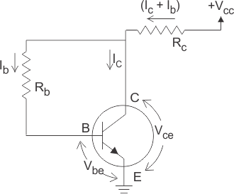
Applying KVL
V_{CC} = (I_{C}+I_{B})R_{C} + V_{CE ………….} (1)
V_{CE} = I_{B}R_{B} + VBE …………….2)
Since, I_{C} = βI_{B} so from equation (1) & (2)
I_{B} = V_{CC} - V_{BE} /(R_{b}+(1+ β)R_{c}
Advantages:
Better stabilization compared to fixed bias.
Disadvantages:
This circuit provides negative feedback which reduces the gain of the amplifier.
Usage:
The feedback also decreases the input impedance of the amplifier as seen from
the base, which can be advantageous. Due to the gain reduction from feedback, this
biasing form is used only when the trade-off for stability is warranted.

Voltage divider bias circuit:
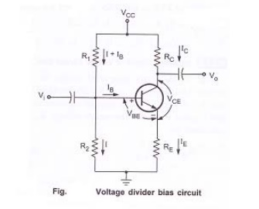
Figure shows the voltage divider bias circuit. In this, biasing is provided by three resistors R₁, R₂ and R_{E.} The resistors R₁& R₂ act as a potential divider giving a fixed voltage to base. If collector current increases due to change in temperature or change in β, emitter current I_{E} also increases and voltage drop across R_{E} increases thus reducing the voltage difference between base and emitter. Due to reduction in base emitter voltage, base current and collector current reduces. So we can say that negative feedback exists in emitter bias circuit. This reduction in collector current compensates for the original change in I_{C}
Circuit analysis:
Fig. Base circuit:
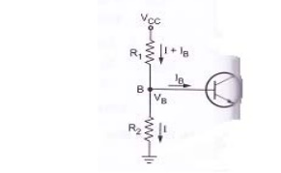
Consider the base circuit as shown in above figure. Voltage across R₂ is base voltage V_{B}. Applying voltage divider rule to find V_{B}

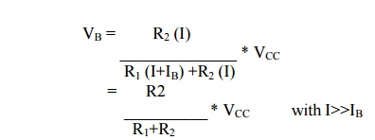
Collector circuit:
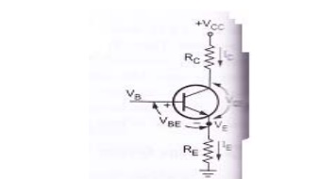
Consider the collector circuit as shown in above figure. Voltage across R_{E} can be obtained as,
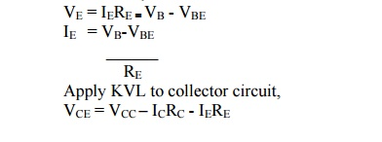
Simplified circuit of voltage divider bias
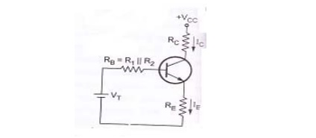
Fig.Thevenin’s equivalent circuit for voltage divider bias.
From above figure, R₁ and R₂ are replaced by R_{B} and V_{T}.
Where R_{B} is the parallel combination of R=1 and R₂
V_{T} is the thevenin’s voltage
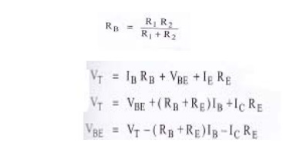
BJT – SMALL SIGNAL ANALYSIS:
In order to develop BJT small-signal models, there are two small-signal resistances that we must first determine. These are:
1.r_{π} : the small-signal, active mode input resistance between the base and emitter, as “seen looking into the base.”
2.r_{e} : the small-signal, active mode output resistance between the base and emitter, as “seen looking into the emitter.” These resistances are not the same, because the transistor is not a so-called reciprocal device. Like a diode, the behavior of the BJT in the circuit changes if we interchange the terminals (i.e., a non-reciprocal device).

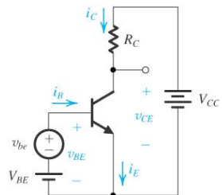

Assuming the transistor is operating in active mode,

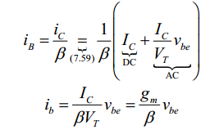
The AC small signal equivalent from the figure is
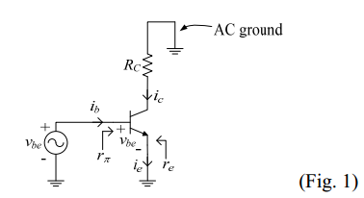
From the small signal equivalent circuit above,
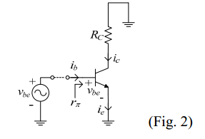
r_{π =} V_{be} /i_{b ; &} r_{π =} β/g_{m ;}
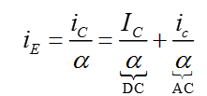

Or with I_{E} = I_{C}/α
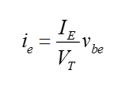
r_{e} is the BJT small signal resistance between emitter and base when looking into the emitter.
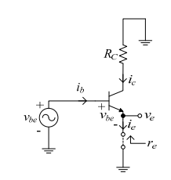
Mathematically this is stated as
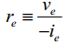
Assuming an ideal signal voltage source, then and
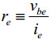
From the above equations ,
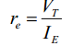 and 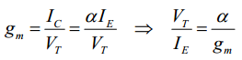
Now r_{e} can be written as
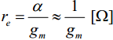 This is the BJT active mode small signal resistance between the base and emitter. And

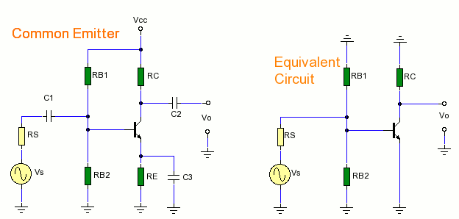
The above figures shows the CE configuration for hybrid analysis and its equivalent circuit.
C1 and C2 are coupling capacitors and c3 is bypass capacitor. Rs is source resistance and Rb1 & RB2 are base resistors in parallel.
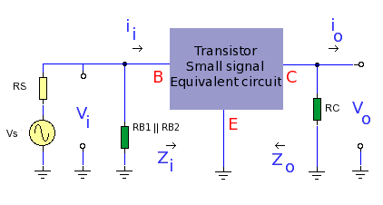
The figure shows hybrid equivalent circuit.
Hybrid model has 4 parameters, h represents hybrid since it is a combination of impedance, admittance and dimensionless parameters.
- h_{ie}= input impedance in ohms
- hre=reverse voltage ratio.(dimensionless)
- hfe= forward current transfer ratio( dimensionless)
- hoe output admittance in Siemens.
The hybrid model for BJT in common emitter mode is shown below.

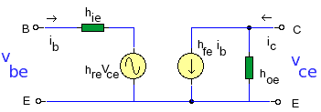

The hybrid model is suitable for small signal at mid band and describes the behavior of transistor. Two equations can be derived from the above diagram , one for input voltage, and the other for output current.

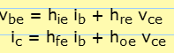
If Ib held constant (Ib=0), then hre and hoe can be observed.
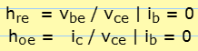
If Vce is held constant, then hie & hfe can be solved.

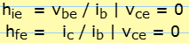

The Figure given below shows the Commom Emitter Vs h-parameter model.
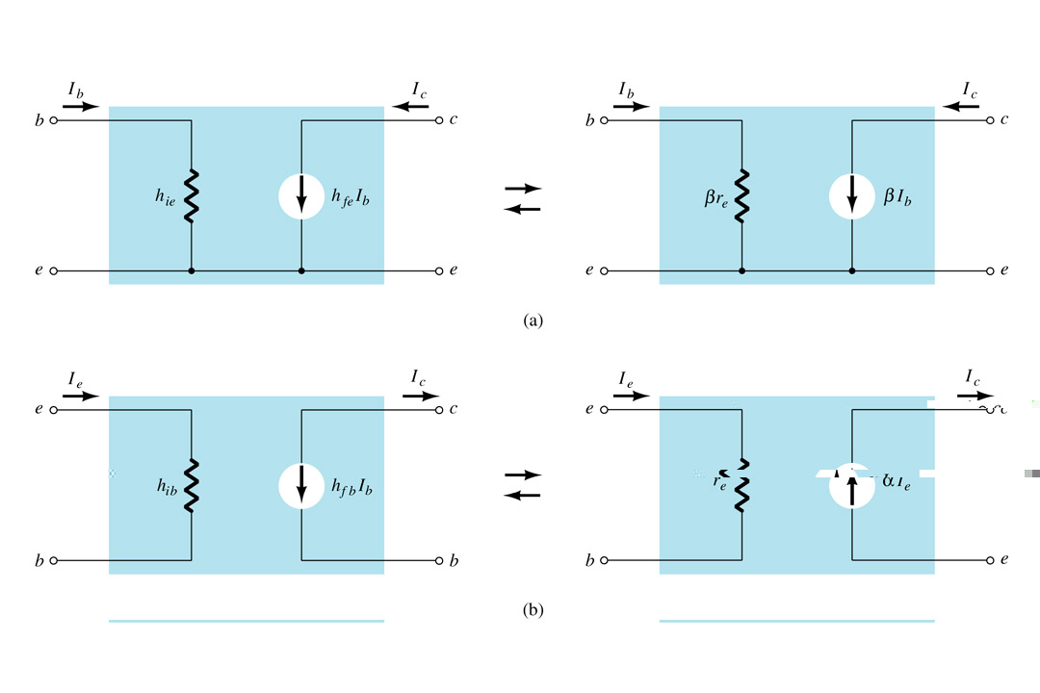

Input Impedance: (Zi):
Input impedance is the parallel combination of base resistors R_{B1} & R_{B2}.
As power supply is considered as short circuit at small signal levels the total resistance at the base is given as R_{BB} = (R_{B1}*R_{B2})/R_{B1}+R_{B2}.
As R_{BB} is parallel with h_{ie} , now input impedance R_{BB}||h_{ie}.

Output Impedance : (Zo):

hfe and ib forms an ideal current generator with infinite ouput impedance, then output impedance Zo is given as
Zo = Rc.

Volatage gain ( Av):
Due to CE configuration output is 180⁰, now output voltage Vo is

Vo= - Io * Rc; -h_{fe} * Ib * Rc:

Ib= (vi/h_{ie} );

= -h_{fe} * (vi/h_{ie} ) * Rc ;

Av = Vo/Vi = -(hfe/hie) * Rc.

Curent Gain (Ai):

It is the ratio of Io/Ii. At the input side, current splits into RBB and hie. By Observing into h parameter model , Ib can be calculated by using current divider rule,

I_{b} =( R_{BB}/I_{i})/ (R_{BB}+h_{ie}) ;

At the output side, Io = hfe.Ib ;

Re- arranging I_{o}/I_{b} = h_{fe} ;

A_{i} =Io/Ii = (Io * I_{b})/ (Ib * Ii).

h_{fe =} R_{BB}/ (R_{BB}+ h_{ie}) :

Ai = Io/Ii = h_{fe}* R_{BB}/ (R_{BB}+ h_{ie}).

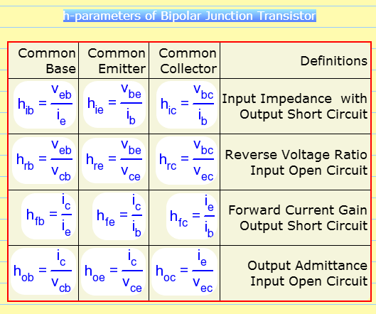

Comparison of CB ,CE and CC Amplifiers:

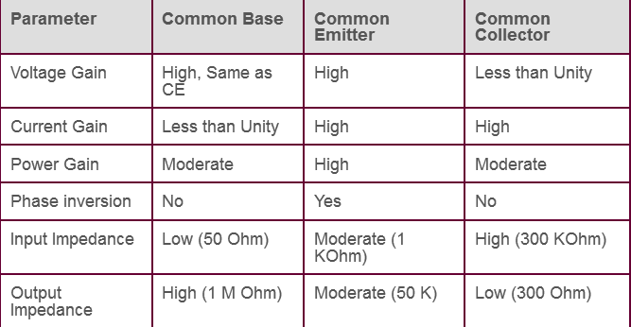

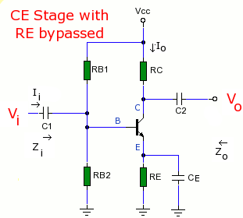
Common emitter amplifier with Emitter resistor Re:
Input resistance:
R_{i} = V_{i} / I_{b};
= [h_{ie} + (1+h_{fe}) * R_{E}]* I_{b} / I_{b};
= [h_{ie}+(1+h_{fe})]*R_{E} .
Input resistance varies much larger than R_{E} . i.e, R_{E} greatly increases the input resistance of the amplifier.

Current gain (Ai)
Ai = -(Ic/I_{b}) = - h_{fe} *I_{b} / I_{b} =-h_{fe};
Voltage gain( Av):
Av = Ai * R_{L} / Ri ;
= - (h_{fe} * R_{L}) / h_{ie} + (1+h_{fe}) * R_{E};
This reduction in gain is compensated by stability improvement.
If (1+hfe)R_{E} >> h_{ie} and h_{fe} >> 1 ;
Now, Av = hfe *R_{E} / (1+h_{fe})* R_{E} = - R_{L}/R_{E}.
Av is completely stable and independent of all transistor parameters.
Output resistance Ro is equal to R_{L} or R_{C} ,which is independent of R_{E}.

Generalized Approximate model :
Hybrid model of CE configuration can be used for approximate analysis.
The signal is connected between input and ground and the load is connected between ground and output.
Current gain (Ai ) :
A_{i}=-h_{fe} / (1+h_{oe}) *R_{C} ; if h_{oe} * R_{C} < 0.1 :
Ai = -h_{fe} ;
Input Impedance Z_{i} ;
Z_{i} = h_{ie} + h_{re} * A_{i} * Rc ;
Z_{i} = h_{ie} { 1- h_{re} * h_{fe} * |A_{i}| * h_{oe} * R_{c} / ( h_{ie} * h_{oe} * h_{fe} ) }
Using the typical values of h – parameters ( h_{re} * h_{fe}) / (h_{ie} * h_{oe}) = 0.5;
And | Ai | = h_{fe} ;
Now, Zi = h_{ie} {1- ( 0.5 * h_{fe} * h_{oe} * R_{L}) / h_{fe}} ; and Z_{i} = h_{ie} = V_{b} / I_{b} ;
Voltage gain (A_{v}) ;
Voltage gain Av = A_{I} * ( R_{L} / R_{i} ) ;
= -h_{fe} * (R_{L} ) / h_{ie} ;

Output Impedance: It is the ratio of V_{c} to Ic with Vs =0 and excluding Rc ;
The actual value of output impedance depends on the source resistance Rs , and lies between
40k ohms to 80K ohms.
Effect of coupling and coupling and bypass capacitors on low frequency response.
The equations for current and voltage gain for a small signal amplifier are applicable in low frequency & mid band frequency regions. The main assumption is the reactance of coupling and bypass capacitance are neglible in these regions.
F α 1/Xc ;
In the above circuit c1 & c2 are coupling capacitors. At low frequencies C1 and C2 are sufficiently large, so that its reactance is small and does not have any effect on the response. Further it is assumed that RB1 & RB2 are much larger than input resistance, Ri, So that they may be neglected in h parameter equivalent circuit.
At mid frequency Av is given as
Av = -hfe* Rc/(Ri+hie);
Effect of Ce : emitter by pass capacitor at low frequency.
Consider Ce is large enough to cause reduction in gain. At low frequencies, the voltage drop across Ce, reduces the gain. The frequency at which the gain drops by a factor of 1/sqrt(2). Is the lower 3dB frequency f1 and is given as
F1= 1/(2*π *(Ri+Ri¹).Cc):
Ri¹ = (R1/R2)||Ri;
With bypass capacitor Ce ; Ri is given as h_{ie} + (1+hfe)R *Ce.
Questions & Problems:
  - Explain the operation of SCR with necessary diagrams.
  - Draw the equivalent circuit of UJT and describe clearly.
  - Explain full-wave rectifier with C-filter and derive necessary expressions.
  - In a center-tapped full-wave rectifier, the rms value of half secondary voltage is 9v. Assuming ideal diodes and load resistance, R_{L =}1K ohm, Find a) DC voltage b) Ripple factor.
  - Explain Biasing concepts in BJT.
  - Draw h- parameter model and derive expressions for input impedance, Output admittance, voltage gain and Current Gain .
  - Compare CB, CE and CC configuration with relevant circuits.
  - Explain DC load line analysis.
Note: Please refer the text books for more problems:
    - Electronic devices & circuits by V.K.Mehta & others by Khanna publishers
    - Electronic devices & circuits by Salivahana.

